

CS 230 Project Software Design Template
Version 1.0

Table of Contents

CS 230 Project Software Design Template 1
Table of Contents 2
Document Revision History 2
Executive Summary 3
Requirements 3
Design Constraints 3
System Architecture View 3
Domain Model 3
Evaluation 4
Recommendations 5

Document Revision History

Version | Date | Author | Comments
1.0 | 5/24/2026 | Ryan Wilder | Software design document for The Gaming Room.

Executive Summary

The Gaming Room owns a game called Draw It or Lose It that currently runs only as an Android app. The client wants the same game as a web-based application that works on multiple platforms. The challenge is to share one game environment across many users without losing track of which game, team, or player belongs to whom.

Requirements

The business requirement is to expand Draw It or Lose It from an Android-only app into a web-based program that reaches users on a wider range of platforms. The technical requirements: a game must support one or more teams, each team must support multiple players, game and team names must be unique, and only one instance of the game environment can exist in memory at any given time.

Design Constraints

- Single game environment in memory: Only one instance of the game can exist in memory.
- Unique game, team, and player names: Names must be unique so users can be told when a name is taken.
- Web-based, multi-platform delivery: The application must run on Android, iOS, Windows, Mac, and Linux.

Domain Model

ProgramDriver starts the application and uses SingletonTester to prove that only one GameService exists. Entity is the base class that holds the id and name. Game, Team, and Player each extend Entity, so all three inherit the same id, name, and getter methods. A game owns a list of Teams, and a Team owns a list of Players. GameService owns the master list of games and hands out the next id whenever a new Game, Team, or Player is created.

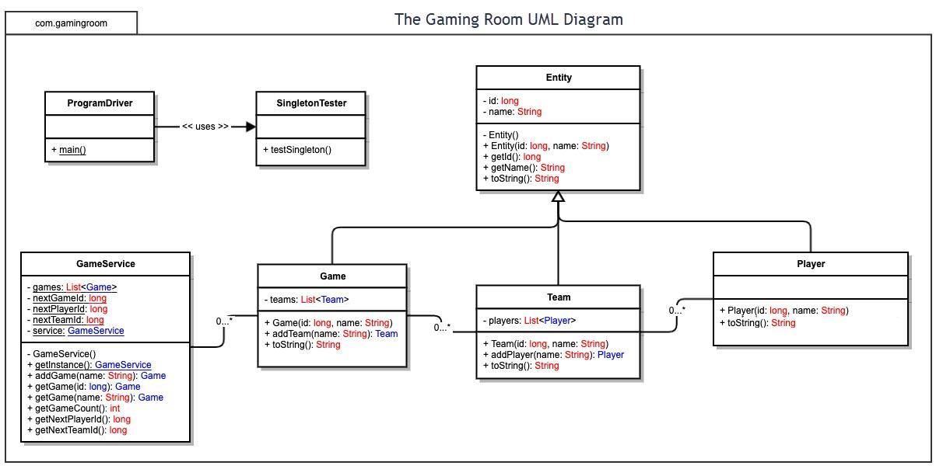

Evaluation

Development Requirements | Mac | Linux | Windows | Mobile Devices
Server Side | Although macOS is built on Unix, it has to run on Apple hardware, which is expensive. It is rarely used to host production web applications. | Linux is the most common web hosting platform. It’s free and open source, very stable, and scales well | Windows Server is reliable and works well with other Microsoft systems, but requires paid licensing. | Mobile devices are not designed to act as servers. They have limited processing power, storage, and memory, which makes them unsuitable for hosting.
Client Side | Mac users reach the game through any modern web browser, so no separate build for Mac is needed. | Linux users also access the game through the browser, so the same web client works with no extra build. | Windows has the largest user base and is reached through the browser, so little extra work is required. | Mobile users can reach the game through their browser, but small screens and touch input require a specific, responsive design.
Development Tools | Mac supports XCode along with standard web tools. | Linux supports Java, JavaScript, and HTML/CSS with IDEs like IntelliJ IDEA, Eclipse, and VSCode. | Windows supports Visual Studio, VS Code, IntelliJ IDEA, and Eclipse. | Native mobile apps use Android Studio (Java/Kotlin) and XCode (Swift).

Recommendations

Analyze the characteristics of and techniques specific to various systems architectures and make a recommendation to The Gaming Room. Specifically, address the following:

- Operating Platform: The recommended server platform is Linux hosted in the cloud. Linux is open source and free of licensing fees. Since the game runs in a web browser, one Linux backend can serve Android, iOS, Windows, Mac, and Linux without separate builds for each platform.

- Operating Systems Architectures: The Linux kernel runs in a protected area called kernel space and manages CPU, memory, devices, files, and the network. Applications like the game server run in user space and reach the kernel only through system calls, which means another program cannot crash the server program. Unlike Windows Server and macOS, Linux is open and portable, and the same code can be used across development, testing, and production.

- Storage Management: Linux should use the ext4 journaling file system with the Logical Volume Manager. LVM lets storage be resized without downtime as more games and players are saved. Since the game must keep unique game, team, and player names and persist game state, structured data belongs in a relational database, while images are best stored in cloud object storage.

- Memory Management: Linux uses virtual memory, which gives each process its own address space mapped to physical RAM. Each process is isolated, so one program cannot read or overwrite another. Since the game is written in Java, it runs in the Java Virtual Machine, which manages its own memory and uses garbage collection to reclaim unused space. This fits the design rule that only one game environment exists in memory.

- Distributed Systems and Networks: The game uses a client-server model where the Linux server holds the one main game environment, and each device runs a lightweight client in its web browser. They communicate over standard web protocols, using Http/Https for normal requests and WebSockets for real-time play. Since these protocols are not platform-specific, the same server reaches every device. The biggest dependency is the internet connection. If the internet connection drops, the design should retry requests and keep the game state on the server so a player can reconnect.

- Security: User information must be protected in transit and on the server. All traffic should be encrypted with TLS and HTTPS so credentials and game data cannot be read or changed. Users should log in, and passwords should be encrypted and never stored as plaintext. Authorization checks should limit each user to their own games, teams, and players. Linux adds protection through its permissions model. A firewall should open only the needed ports, and all client input should be validated to block injection attacks.

